LiFePO4 Battery Specification
Model: TB12V100Ah-HEAT-L

- General Information
This specification defines the performance of rechargeable LiFePO4 battery pack TB12V100Ah-HEAT-L manufactured by TOPBAND, it describes the type, performance, technical characteristics, warning and caution of the battery pack.

- Battery Pack Specification（@ 25±2℃）
No. | Items |  | Parameters
2.1 | Nominal voltage |  | 12.8V
2.2 | Nominal energy@0.2C |  | 1280.0Wh
2.3 | Nominal capacity@0.2C |  | 100.0Ah
2.4 | Internal resistance@1khz AC |  | ＜30.0mΩ
2.5 | Charge voltage range |  | 14.0~14.6V
2.6 | Float voltage range |  | 13.6~13.8V
2.7 | Allowed MAX charge current |  | 100.0A
2.8 | Recommend charge current |  | 80.0A
2.9 | Allowed MAX discharge current |  | 100.0A
2.10 | Recommend discharge current |  | 80.0A
2.11 | Peak/Surge current limit |  | 360A@3S
2.12 | Short circuit protection |  | Yes
2.13 | End of discharge | Inverter/Load cut off | 11.2V
2.13 | End of discharge | BLVD | 10.0V
2.13 | End of discharge | Re-connect voltage | 12.0V
2.14 | Communication | Bluetooth | TBEnergy
2.14 | Communication | Port | /
2.15 | Parallel and Series connection |  | Support  Max. 4 in series or Max.4 in parallel
2.16 | Terminal and torque |  | M8/10N.M
2.17 | IP rating |  | IP54
2.18 | Dimension |  | L 306.8mm
2.18 |  |  | W 167.8mm
2.18 |  |  | H 210.6mm
2.19 | Weight (without accessories) |  | 11.5±0.5kg
2.20 | Operation temperature¹ | Charge | 0~45℃ | 0~10℃: ≤0.3C (Force)
 |  |  |  | 10~20℃: ≤0.5C
 |  |  |  | 20~35℃: ≤1C
 |  |  |  | 35~45℃: ≤0.5C
2.20 | Operation temperature¹ | Discharge | -10～60℃
2.21 | Operation altitude |  | <3000m
2.22 | Self-discharge rate² | Residual capacity | ≤3%/month | ≤15%/year
2.22 | Self-discharge rate² | Recover capacity | ≤1.5%/Month | ≤8%/ year
2.23 | Storage environment³ | ≤6 months | 0℃<T<30℃
2.23 | Storage environment³ | ≤3 months | -10℃<T<45℃
2.23 | Storage environment³ | Recommend environment | 15～35℃|4 5～75%RH
2.24 | Cycle life |  | >2000 times
Note | ¹ Battery pack will stop work to protect itself when the temperature is out of the operation range. The optimum operating temperature range is from 15°C to 35°C, Frequent exposure to the harsh temperatures may worsen the performance of the battery pack and cycle life.  ²These conditions is based on battery pack is in sleep or power off mode.  ³For long time storage, we recommend charge the battery over 50% SOC and if the battery does not have a sleep or power off mode, please consult TOPBAND first.

- Electrical Specification
Test conditions: Ambient Temperature: 25±2℃, Humidity:10%~75%.
Normal charge：Charge battery under CC(0.2C)/CV(14.6V)mode until over charge protection or the charge current reduce to 0.02C, and then rest for 1h.

No. | Items | Criterion |  | Test Condition
3.1 | Rated Capacity | 100.0Ah |  | After Normal charge, discharge @0.2C current to the end of discharge voltage.
3.1 | Min. capacity | 98.0Ah
3.2 | Internal Impedance | ≤30.0mΩ |  | @50% SOC @1kHz AC internal resistance test instrument.
3.3 | Short circuit protection | Auto cutoff load when short circuit |  | Connect the positive and negative of this battery pack through a lead with 0.1Ω resistance.
3.4 | Cycle life | ≥2000 cycles |  | After Normal charge，discharge @0.2C current with 80%DOD, Repeat above process until discharge capacity reduce to 80% of initial value.
3.5 | Discharge temperature  characteristic@0.2C | -20℃(6h) | ≥70% | the percentage  accord with criterion  Capacity @specified temperature  Capacity @ 25℃
3.5 | Discharge temperature  characteristic@0.2C | 0℃(6h) | ≥80%
3.5 | Discharge temperature  characteristic@0.2C | 25℃(4h) | ≥100%
3.5 | Discharge temperature  characteristic@0.2C | 55℃(4h) | ≥95%
3.6 | Capacity retention rate | Remain capacity  ≥80% |  | After normal charge, store the battery @25±2℃for 28days, then discharge capacity @0.2C to the end of discharge voltage，the retention capacity accord with criterion.

- Battery quick guide
4.1 Dimensions
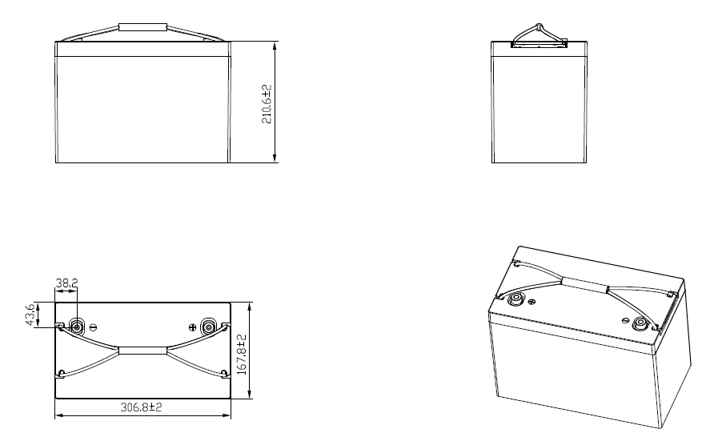
4.2 Transport & Storage
- Do not violently shake, impact or squeeze, and prevent sun and rain during the transportation.
- Do light take and put and strictly prevent falling, rolling, and heavy pressure during loading and unloading.
- The battery should be placed in a dry, clean, dark, and well-ventilated indoor environment for long-term storage, and the recommended storage temperature range is 15~35℃.
- No harmful gases, flammable and explosive products and corrosive chemical substances in the storage location.
- The batteries should be stored and transported in close to 50% SOC.
- If do not use for a long time, the battery needs to be charged every 6 months according to the specs.
- No fall down, no pile up over 6 layers, and keep face up.

4.3 Warning & Tips.
Please read battery specification or manual carefully before use. Improper use may cause heat, fire, rupture, damage or capacity deterioration of the battery. TOPBAND will not be responsible for any accidents caused by the usage without following our handling instructions.

Warning
- Battery must be far away from heat source, high voltage, and direct exposed to sunshine.
- Never throw the battery into water or fire.
- Never reverse two terminals when using the battery.
- Never connect the positive and negative of battery with conductor.
- Never knock, throw or trample the battery.
- Never disassemble the battery without manufacturer's permission and guidance.
- Never mixed battery with different capacity and brand;

Tips
- It is suggested to fully charged the battery per month to correct the battery SOC.
- Please charge your battery timely (≤2day) when battery runs out of power.
- Please use the dedicated lithium battery charger to charge the battery.
- Stop using when battery emit peculiar smell, heating, distortion or appear any abnormity
- Please keep the battery far away from children or pets.
- If the battery pack leaks electrolyte, avoid contacting with the liquid or gas leakage if the electrolyte of battery pack leaks, please take these steps immediately:
Gas Inhalation: Evacuate the people in the contaminated area and seek medical aid as soon as possible.
Eye Contact: Flush your eye with clean and flowing water for 15 min, and seek medical aid as soon as possible.
Skin Contact: Thoroughly rinse the exposed area with soap and water to be sure no chemical or soap is left on them, and seek medical aid as soon as possible.
Swallowing: Try to induce vomiting, seeks medical aid as soon as possible immediately.
Fire: Please use carbon dioxide fire extinguisher rather than liquid to put out fires.

